# Git-lab 1

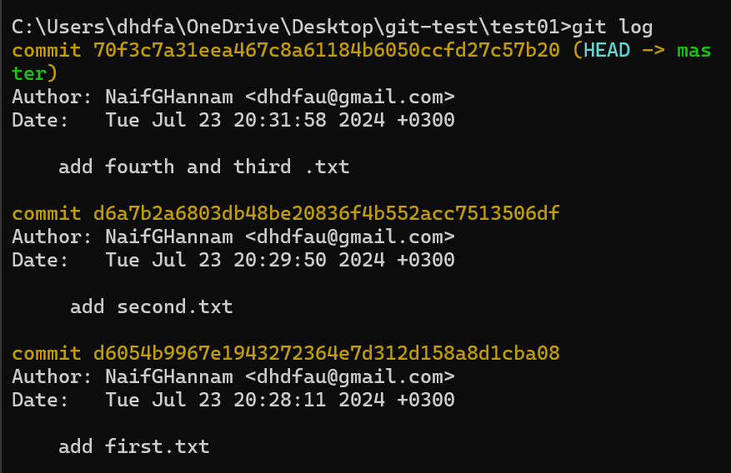

# Git-lab 2

# git-lab 3

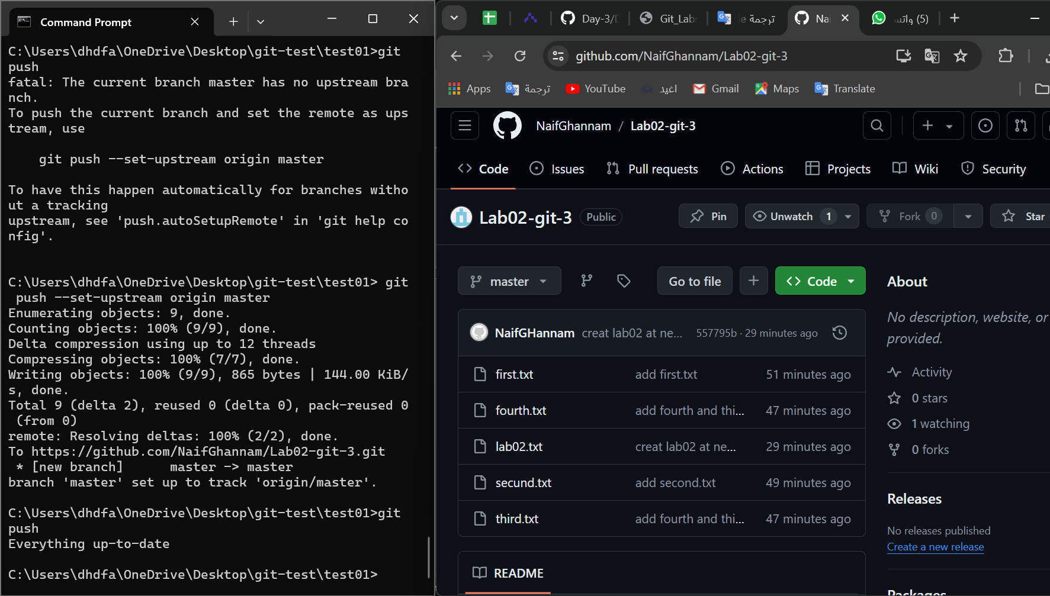

# Lab_python1.1

## Task-1

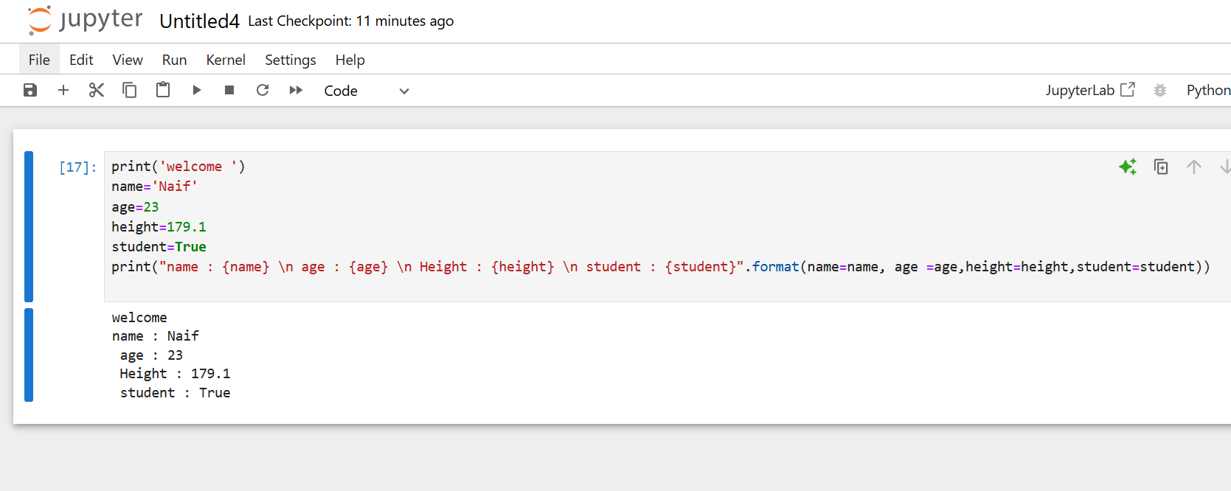

## Task-2

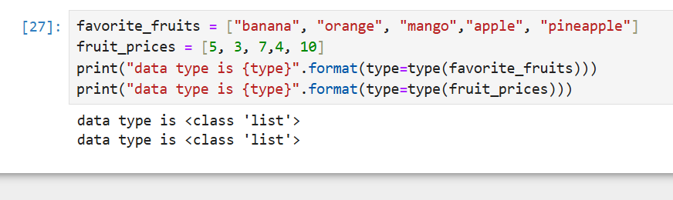

## Task-3

### 1

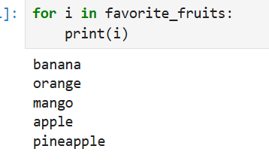

# LAB_pyton1.2

## 1

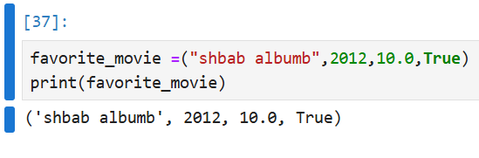

## 2

